EXP 24

AIM: Design DFA using simulator to accept the string having ‘ab’ as substring over the set

{a,b}

INPUT:

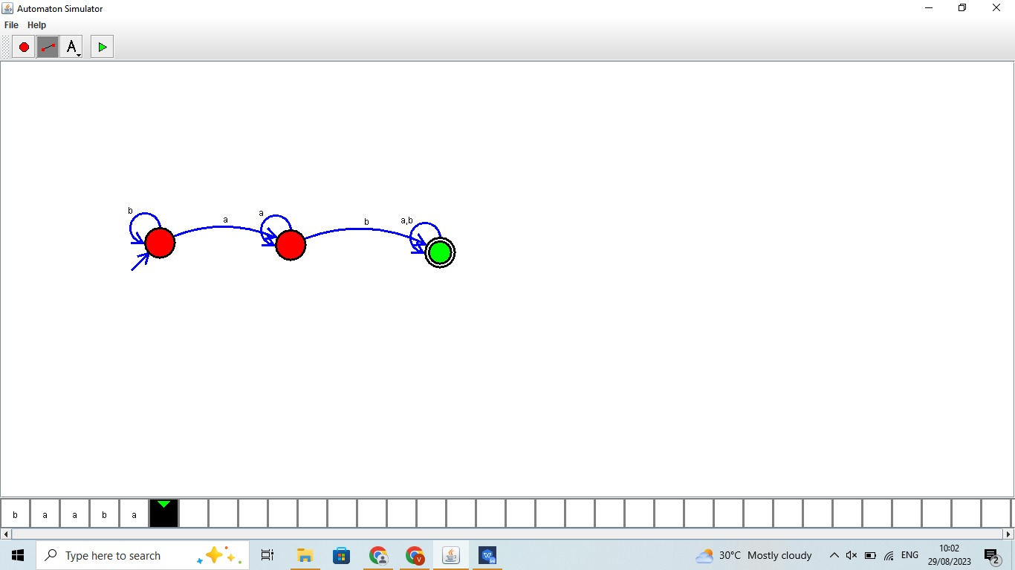

OUTPUT:



RESULT: Design DFA using simulator to accept the string having ‘ab’ as substring over the set

{a,b} Is successfully verifed